Click for Video:

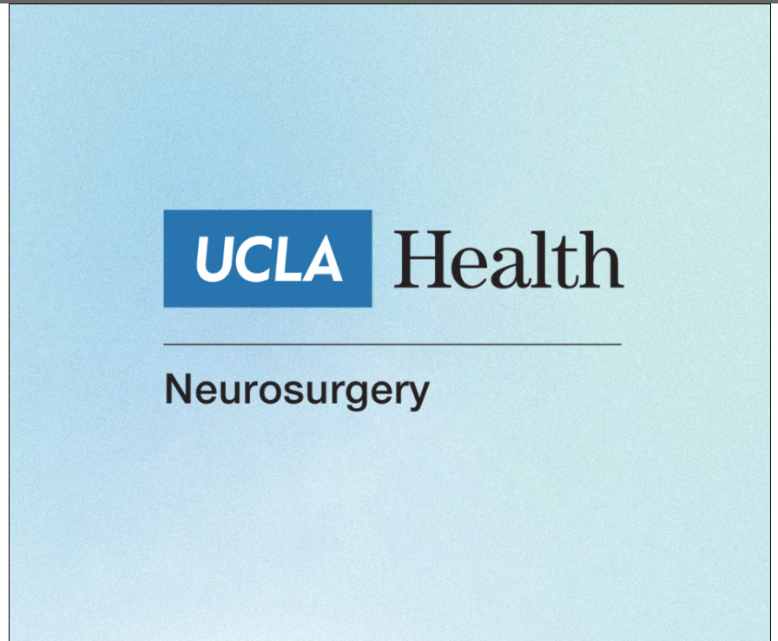

https://www.uclahealth.org/departments/neurosurgery/education/residency-training

