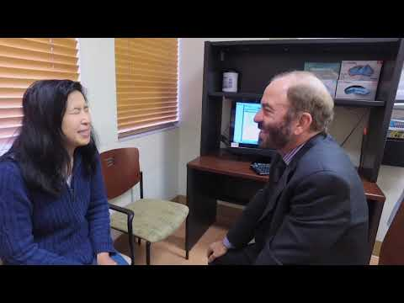 | Stanford Neurosurgery Residency Program - Perspectives from Faculty and Residents  Learn more about the Stanford Neurosurgery Residency Program at: http://dura.stanford.edu  www.youtube.com

https://www.youtube.com/watch?v=_ICcYnydtJ4&ab_channel=StanfordNeurosurgery

